# Usability

* Requirements : user-friendly

The *U.S. Human Engineering Design Criteria for Military Systems* (1999) states these purposes:

* + Achieve required performance by users
  + Minimize skill and personnel requirements and training time
  + Achieve required reliability of personnel-equipment/software combinations
  + Foster design standardization within and among systems

Usability requires project management careful attention to requirements analysis and testing for clearly defined objectives

**Goals for requirements analysis**

* **Ascertain the user’s needs**
* **Ensure reliability**
* **Promote standardization, integration, consistency, and portability**
* ***Complete projects on time and within budget***

*Standardization*: use pre-existing industry standards where they exist to aid learning and avoid errors

*Integration*: the product should be able to run across different software tools and packages

*Portability*: allow for the user to convert data across multiple software and hardware environments

*Consistency*:

* + - compatibility across different product versions
    - compatibility with related paper and other non-computer based systems
    - use common action sequences, terms, units, colors, etc. within the program

5 human factors central to community evaluation:

* + *Time to learn*
  + *Speed of performance*
  + *Rate of errors by users*
  + *Retention over time*
  + *Subjective satisfaction*

CH#2

Smith and Mosier (1986) offer five high-level goals

* + Consistency of data display
  + Efficient information assimilation by the user
  + Minimal memory load on the user
  + Compatibility of data display with data entry
  + Flexibility for user control of data display

**user’s Keep attention**

* Intensity
* Marking
* Size
* Choice of fonts
* Inverse video
* Blinking
* Color
* Audio

**Five primary interaction styles**

* Direct Manipulation : usually involves a pointing device (a mouse, a stylus, a trackball)
* Menu Selection
* Form fill-in
* Command Language
* Natural Language

**The 8 golden rules of interface design**

1. Strive for consistency
2. Cater to universal usability
3. Offer informative feedback
4. Design dialogs to yield closure
5. Prevent errors
6. Permit easy reversal of actions
7. Support internal locus of control
8. Reduce short term memory load

Prevent errors

Mistakes and slips (Norman, 1983)

* Correct actions
  + Gray out inappropriate actions
  + Selection rather than freestyle typing
  + Automatic completion
* Complete sequences
  + Single abstract commands
  + Macros and subroutines
* **Explanatory theories:**
  + Observing behavior
  + Describing activity
  + Conceiving of designs
  + Comparing high-level concepts of two designs
  + Training
* **Predictive theories:**
  + Enable designers to compare proposed designs for execution time or error rates
* **Perceptual or Cognitive subtasks theories**
  + Predicting reading times for free text, lists, or formatted displays
* **Motor-task performance times theories:**
  + Predicting keystroking or pointing times

* **Taxonomy   
  (explanatory theory)**
  + Order on a complex set of phenomena
  + Facilitate useful comparisons
  + Organize a topic for newcomers
  + Guide designers
  + Indicate opportunities for novel products
* **Foley and van Dam four-level approach** 
  + ***Conceptual level:*** 
    - **User's mental model of the interactive system**
  + ***Semantic level:*** 
    - **Describes the meanings conveyed by the user's command input and by the computer's output display**
  + ***Syntactic level:*** 
    - **Defines how the units (words) that convey semantics are assembled into a complete sentence that instructs the computer to perform a certain task**
  + ***Lexical level:*** 
    - **Deals with device dependencies and with the precise mechanisms by which a user specifies the syntax**

Approach is convenient for designers

* Top-down nature is easy to explain
* Matches the software architecture
* Allows for useful modularity during design

**Inconsistent action verbs**

* + Take longer to learn
  + Cause more errors
  + Slow down users
  + Harder for users to remember

**Four principles of good design**

* + State and the action alternatives should be visible
  + Should be a good conceptual model with a consistent system image
  + Interface should include good mappings that reveal the relationships between stages
  + User should receive continuous feedback

**Four critical points where user failures can occur**

* + Users can form an inadequate goal
  + Might not find the correct interface object because of an incomprehensible label or icon
  + May not know how to specify or execute a desired action
  + May receive inappropriate or misleading feedback

**Norman's seven stages of action**

* 1. **Forming the goal**
  2. **Forming the intention**
  3. **Specifying the action**
  4. **Executing the action**
  5. **Perceiving the system state**
  6. **Interpreting the system state**
  7. **Evaluating the outcome**

**Norman's contributions**

* + - **Context of cycles of action and evaluation.**
    - ***Gulf of execution:* Mismatch between the user's intentions and the allowable actions**
    - ***Gulf of evaluation:* Mismatch between the system's representation and the users' expectations**

Ch#3

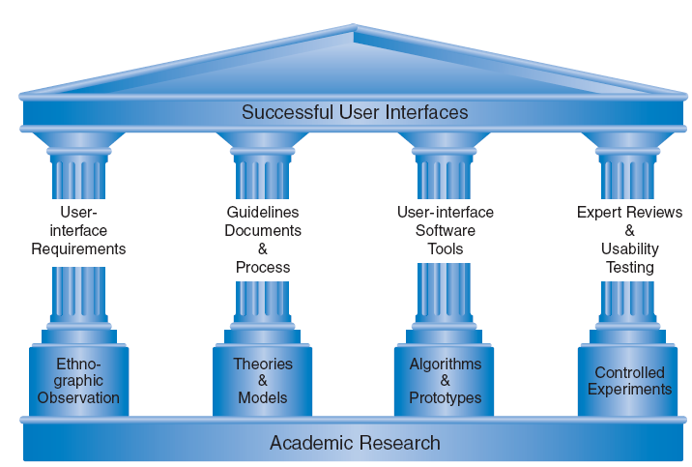

* **Ethnographic Observation**
  + Identifying and observing the user community in action

**Ethnographic Observation**

* **Preparation**
* **Field Study**
* **Analysis**
* **Reporting**

Ch#4

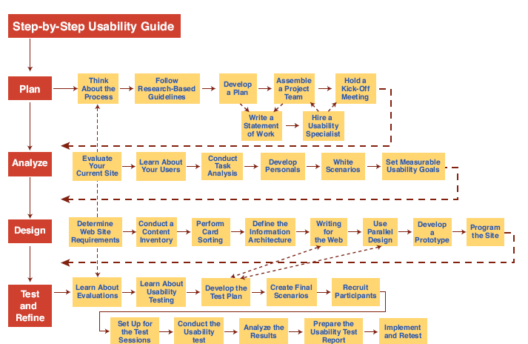

* There are a variety of expert review methods to choose from:
  + Heuristic evaluation
  + Guidelines review
  + Consistency inspection
  + Cognitive walkthrough
  + Metaphors of human thinking
  + Formal usability inspection

"user friendly," measurable criteria for the user interface can be established for the following:

* + Time to learn specific functions
  + Speed of task performance
  + Rate of errors by users
  + Human retention of commands over time
  + Subjective user satisfaction

Ch#5

**Direct-Manipulation Systems**

What's better between CLI or GUI ?

CLI better than for GUI due of speed, and less computer resources & Strain

**Command line vs. display editors and word processors**

**Problems with direct manipulation**

* Spatial or visual representations can be too spread out
* High-level flowcharts and database-schema can become confusing
* Designs may force valuable information off of the screen
* Users must learn the graphical representations
* The visual representation may be misleading
* Typing commands with the keyboard may be faster

**Principles of Direct Manipulation**

1. Continuous representations of the objects and actions.
2. Physical actions or presses.
3. Rapid, incremental.

Ch#7

**The Basic Goals of Language Design**

* Precision
* Compactness
* Ease in writing and reading
* Speed in learning
* Simplicity to reduce errors
* Ease of retention over time

**Hierarchical command structure**

